**Definition: Create Prototype-Animation and transition in Figma.**

**Solution:**

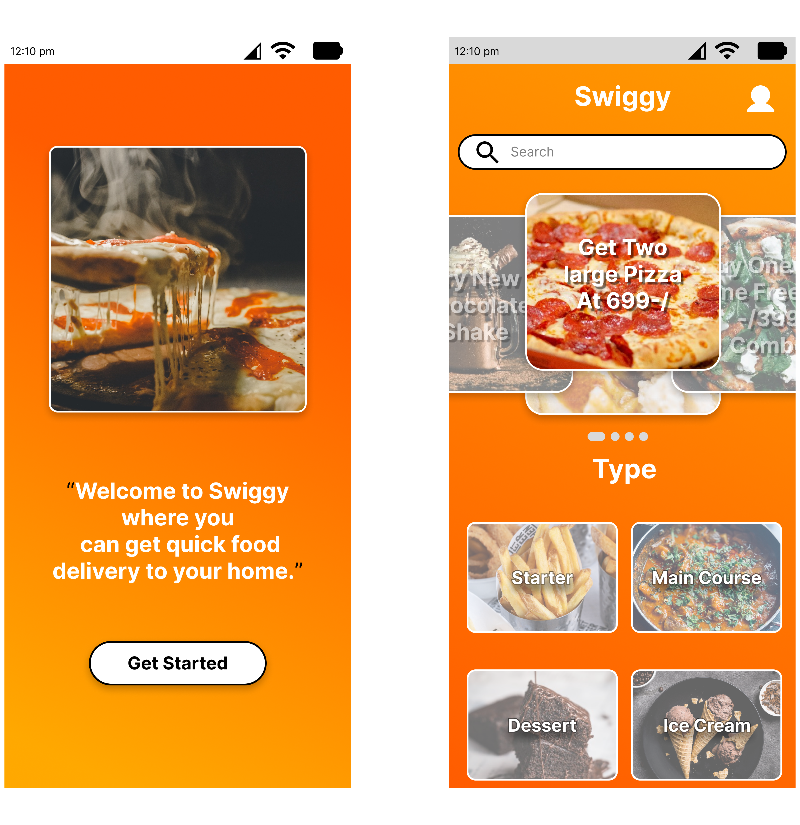

**Steps:**

* First Open Figma in browser mode.
* Then create the new document **File à New Figma Design.**
* Now add one frame using the Frame tool with width=”**1030 px”** and height=”**680 px”** on your canvas give linear gradient color=”**#FC3838**”,”**#FDCD3D**”.
* Take Text tool and write **“LOGO”** on the top-left side of the frame with font**=”50”.**
* Now on the top-right side of frame write **“Home Popular Trending About Us”** of font=**”30”.**
* Select both text to add responsive Autolayout of Horizontal resizing=**”Fill”** and Vertical resizing=”**Hug**”.
* Take an image of width=”**780 px”** and height=”**470 px”.** To make look like scrollable use text tool to add **“<”**,**”>”** and **”.....”.** Select text and image to add responsive Autolayout of Horizontal resizing=**”Fixed”** and Vertical resizing=”**Fixed**”.
* Now to make footer write **“Copyright @2023 Gaurav”** of font=**”25”** on the bottom-left side of the frame.
* Take Rectangle of width=”**150 px”,** height=”**40 px”** and corner radios**=”60”** to make **Contact us** Button.
* Write “**Contact us**” of font**=”20”** and color=”**#FC3838**”,”**#FDCD3D**”. Select Rectangle and text to add responsive Autolayout of Horizontal resizing=**”Fixed”** and Vertical resizing=”**Fill**”.
* Select Above autolayout and **Copyright** text to add responsive Autolayout of Horizontal resizing=**”Fill”** and Vertical resizing=”**Hug**”.
* Now, Go to the **Export** button in the property panel. And **Export** it with .**JPG/.PNG** format.